• Configure password policy must change every 60 days, minimum length 6 digits with complex password and remember last 3 password.

•Force account lock for 1 hour after entering wrong password 4 times

•Enable remote desktop connection for all machines in the domain.

=============================================
هنعمل ايديت للديفولت بوليسز اللي هي موجودة اصلا وتعدل عليها بما يناسب المطلوب
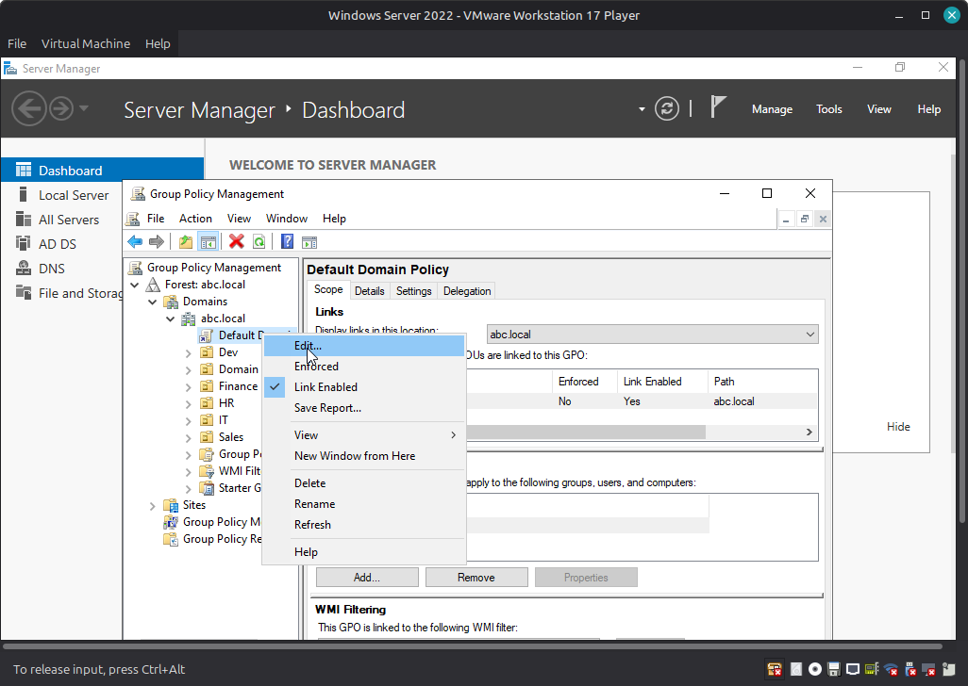

• Configure password policy must change every 60 days, minimum length 6 digits with complex password and remember last 3 password.
هنلاقيهم كلهم في الواجهة دي وتم ضبطهم كما مطلوب
Path>>group policy management editor >computer configuration >policies>windows settings>Account Policies> Password Policy

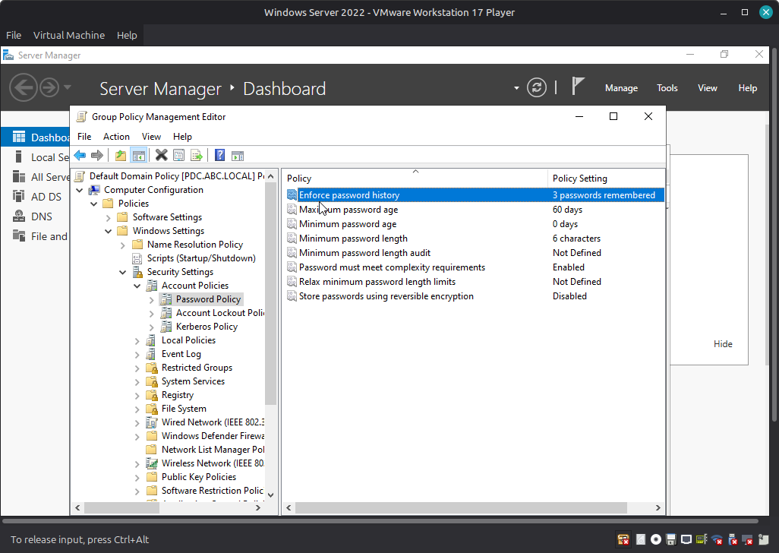
=============
•Force account lock for 1 hour after entering wrong password 4 times

Path>>group policy management editor >computer configuration >policies>windows settings>Account Policies> Account Lockout Policy

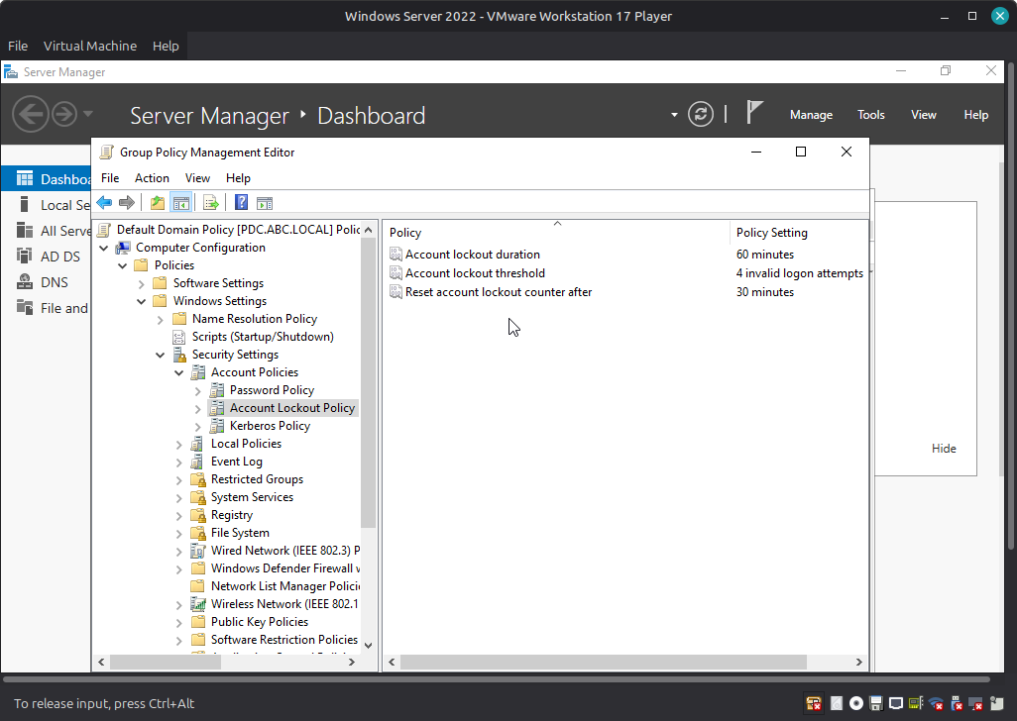
==============
•Enable remote desktop connection for all machines in the domain.

Path>>group policy management editor >computer configuration >policies>windows setting >Adminstrative Policies>Windows Commponents>Remote Desktop Servicies>Remote Desktop Session Host>Connections

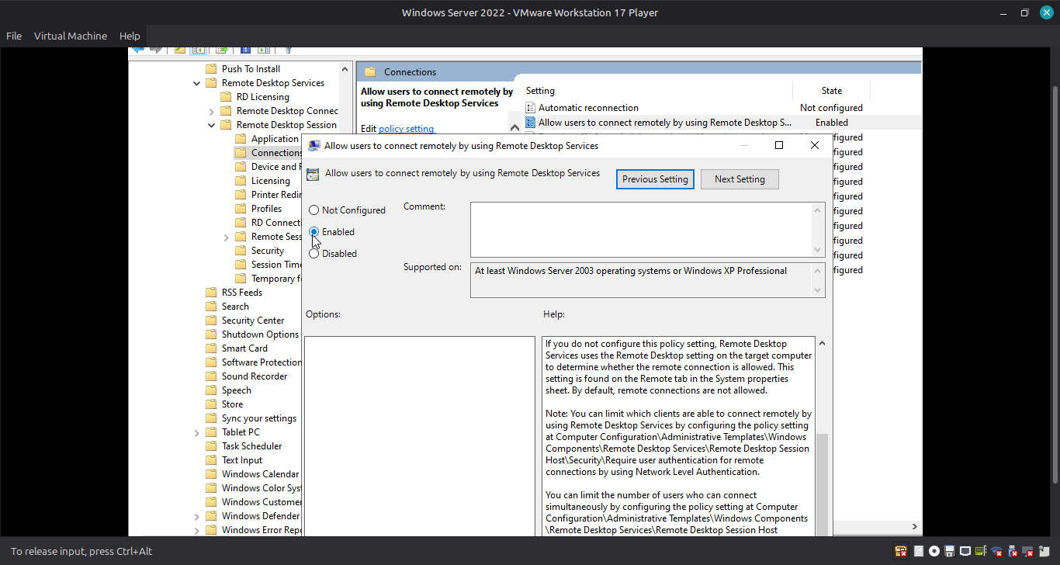
ثم بعد ذلك
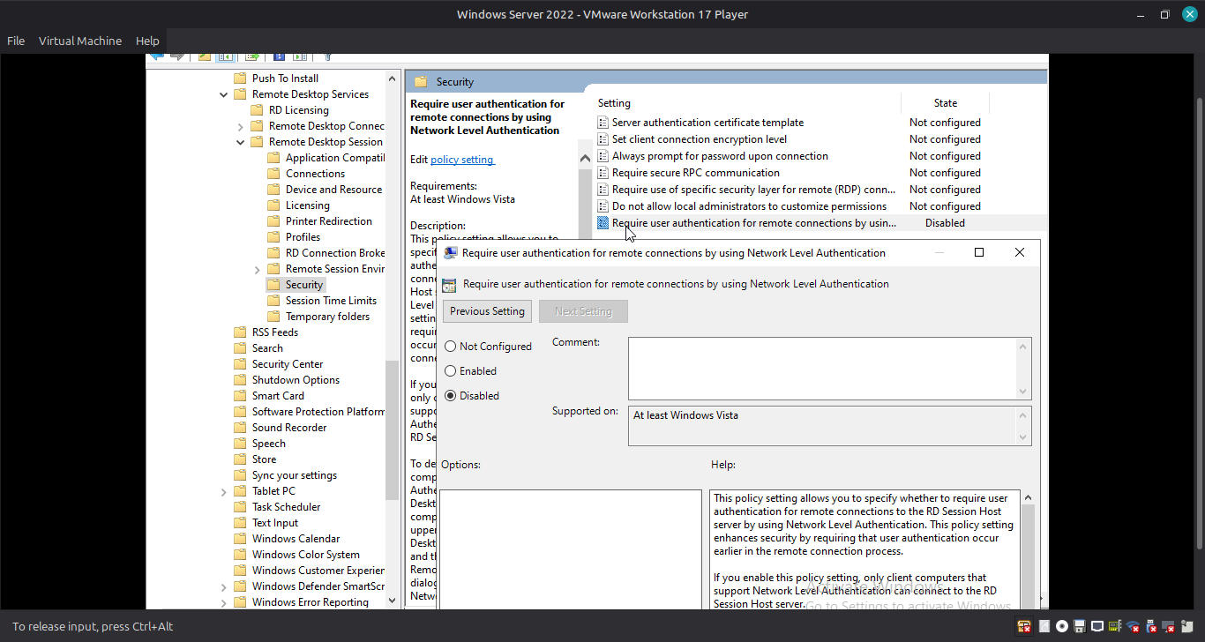
Path>>group policy management editor >computer configuration >policies>windows setting >Adminstrative Policies>Windows Commponents>Remote Desktop Servicies>Remote Desktop Session Host>Security

=next step
Path>>group policy management editor >computer configuration >policies>windows setting >windows Defender Firewall with advanced Security>windows Defender Firewall with advanced Security -LDAP>Inbound Rules(right click ,new rule)
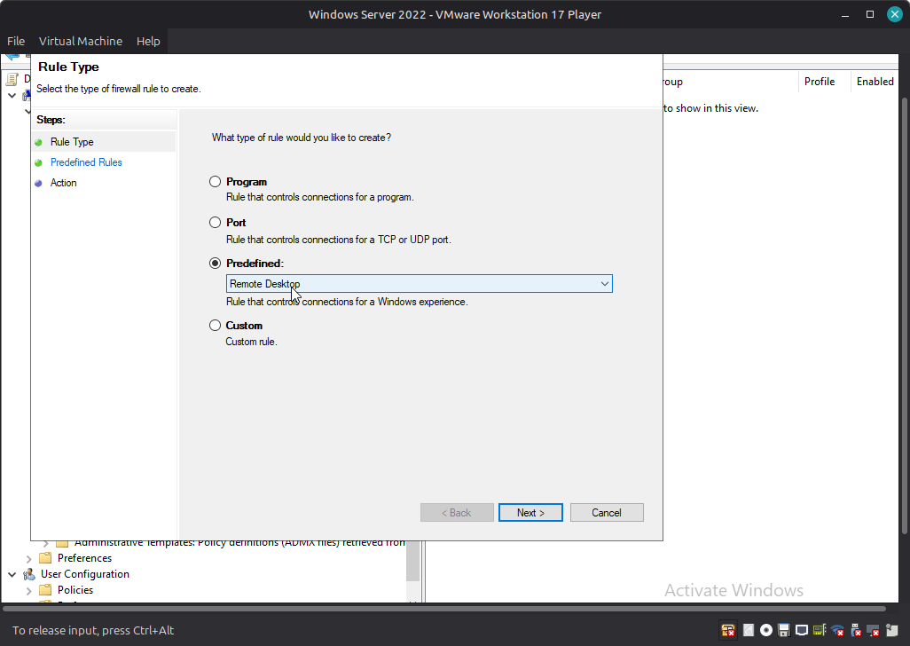
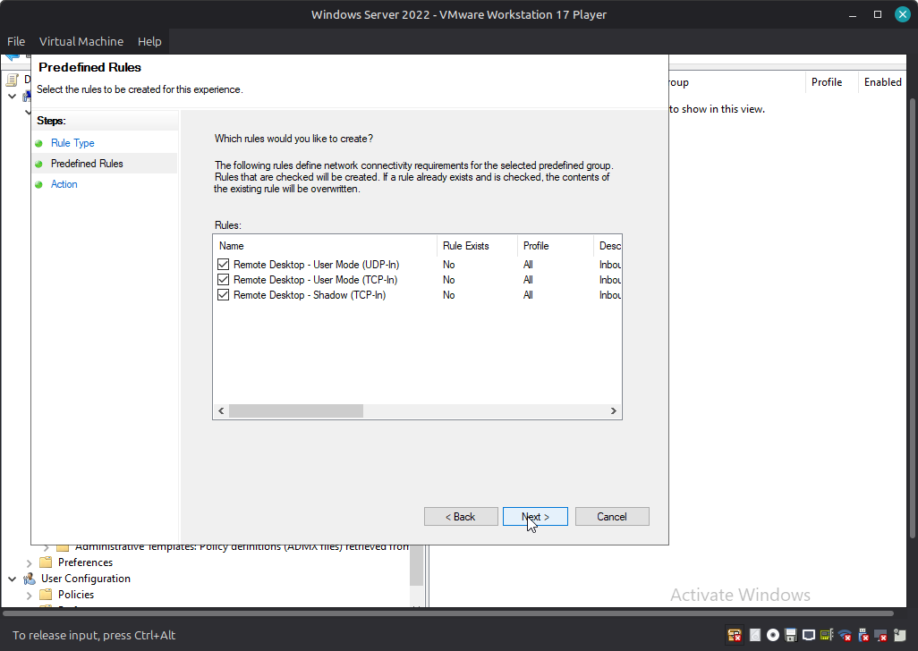
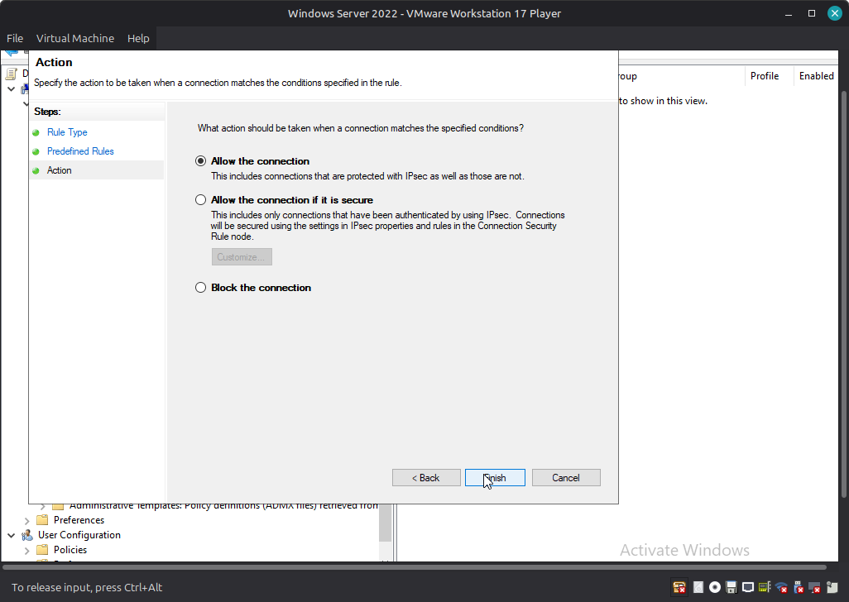

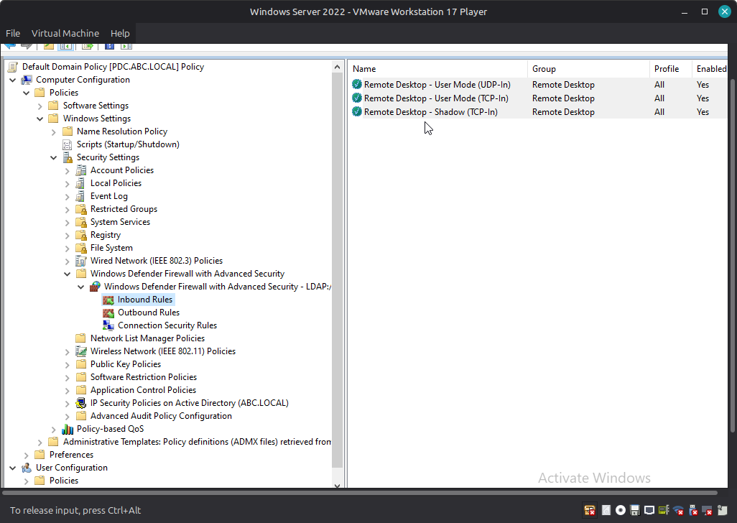
=we finished , don’t forget wirte in cmd (gpupdate /force)

